LR-A020 Vicat Temperature Softening Point Temperature(HDT) Tester

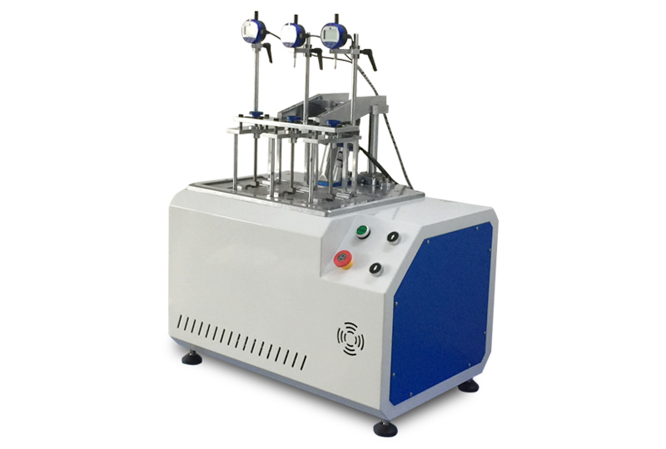

1.Product Introduction：
Thermal Deformation Vicat, Softening Point Temperature Tester is using PLC programmable controller temperature control using computer display operation.The product is simple to operate, convenient to use, stable in performance, high in precision, and can monitor the test temperature and deformation amount in real time during the test.At the end of the test, the system automatically stops heating and can print test reports and test curves.This series of machines are necessary instruments for self-inspection by quality inspection units, colleges and universities and enterprises.
2、Product Character:
Have sample frame lifting function, can at the end of the trial begins or lifting or lowering the specimen holder, this machine is mainly used for non-metallic materials such as plastic, rubber, nylon, electrical insulating materials of the thermal deformation temperature and vicat softening point temperature measurement.
3.Test Standard：
- GB／T1633《Determination of vika softening temperature (VST) of thermoplastic》
- GB／T1634《Determination of plastic load deformation temperature - part 1: general test method》
- GB/T8802《Determination of softening temperature of plastic pipe fittings》
- IS075-2013《Measurement of plastic load deformation temperature》
- ASTM D 648《Test method for temperature of plastic thermal deformation》
- ASTM D 1525《Plastic Vicat softening test method.
4. Technical specification：
- Temperature control range：Normal temp—300℃
- Heating speed：（120±10）℃/h (12±1)℃/6min
(50±5)℃/h (5±0.5)℃/6min
- Temperature indication error：0.1℃
- Temperature control accuracy：±0.5℃
- Maximum deformation indication error：±0.001mm
- Deformation measurement range：0—2mm
- Number of sample frames：3pcs
- Load rod and tray weight：68g
- Test span range: 64 or 100mm (according to the standard)
- Heating medium: methyl silicone oil or transformer oil
- Cooling method: more than 150 natural cooling, 150 under water or natural cooling
- Heating power：4kw
5.Accessories
1. Computer (configuration: industrial computer) 1PCS
2. Printer Ipcs(HP,optional)
3. Electric control box 1pcs
4. Host machine 1pcs
5. Sample shelf frames 3pcs
6. Hot deformation pressure heads 3pcs
7. Vicat needles 3pcs
8.sets of weights (including weights in boxes) (attached table) 3set
9. Multi-purpose power socket 1pcs

6.Attached form :(accept non-standard customization)
Weight | Qty Pcs | Weight | Qty Pcs
1000g | 12 | 932 | 3
500g | 3 | 200g | 6
100g | 3 | 50g | 3
20g | 6 | 10g | 6
5g | 3 | 2g | 3
1g | 3

Software

